Engine

1. Please identify where the Cylinder Head of the engine is located.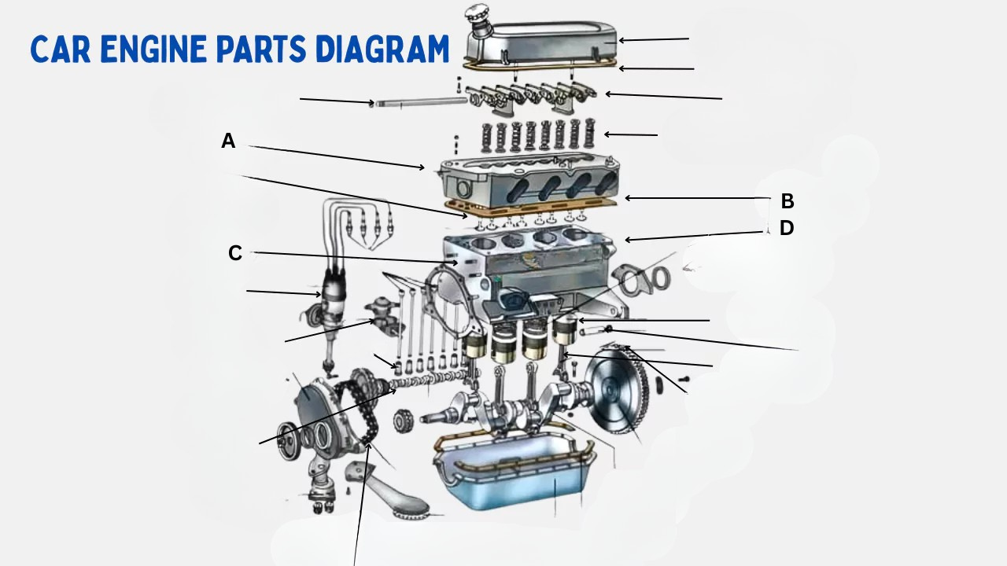

A. A

B. B

C. C

D. D

**Correct answer:** A

1. Please identify where the Fuel Pump of the engine is located.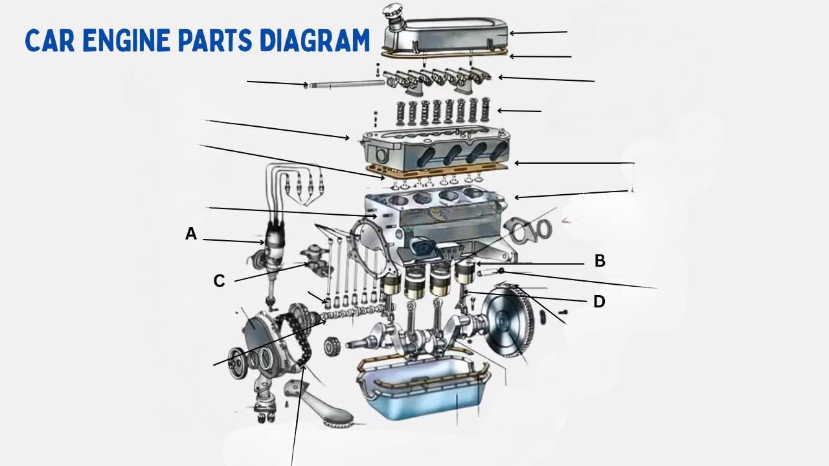

A. A

B. B

C. C

D. D

**Correct answer:** C

1. Please identify where the Crank Shaft of the engine is located.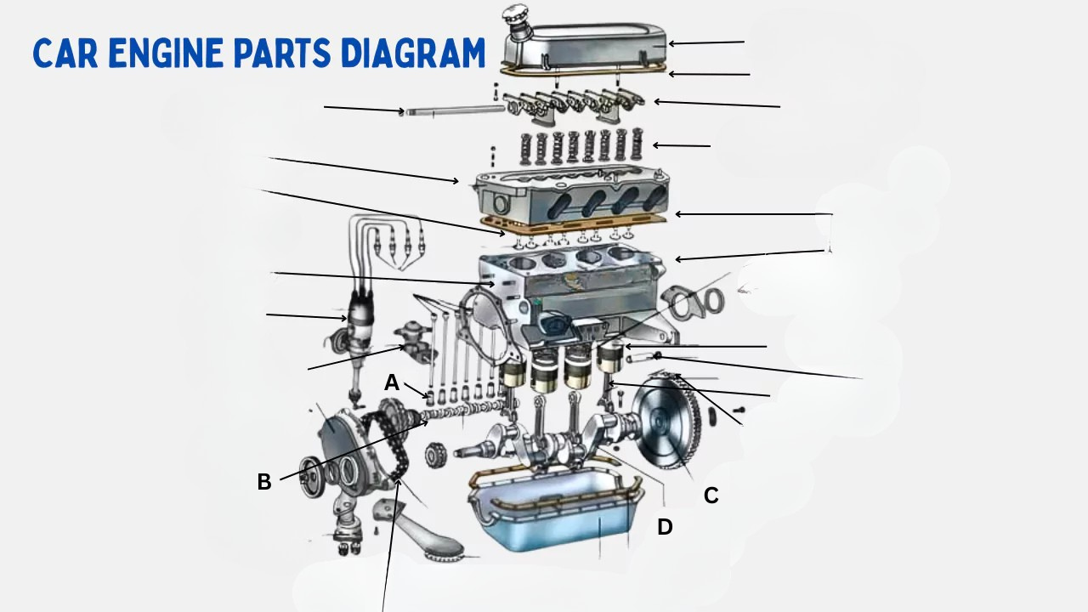

A. A

B. B

C. C

D. D

**Correct answer:** D